Pricing & Commission
Meesho charges 0% Commission rate across all categories, allowing sellers to retain their full earnings on every sale.

No Registration Fee
Registering as a Meesho seller is free - no cost of creating your account or getting your products listed.

No Collection Fee
You keep 100% of the sale price with no charges on both payment gateway or cash on delivery orders on Meesho.

No Penalty
Sell on Meesho stress-free without the fear of
penalties for order cancellations.
Payment Cycle
The settlement amount is securely deposited directly into your bank account following a 7-day payment cycle from order delivery, including cash on delivery orders. You can view your deposited balance and the upcoming payments on the Meesho Supplier Panel.

7-day payment cycle

Secured payment
in your account
Quick Facts on Shipping & Delivery
Shipping
- Meesho’s shipping service allows you to focus on selling, while we take care of the shipping and delivery with only 18% GST on the shipping charges. You can sell your products to crores of Meesho customers, schedule delivery with access to tens of thousands of local couriers, and have the flexibility to set your own prices.
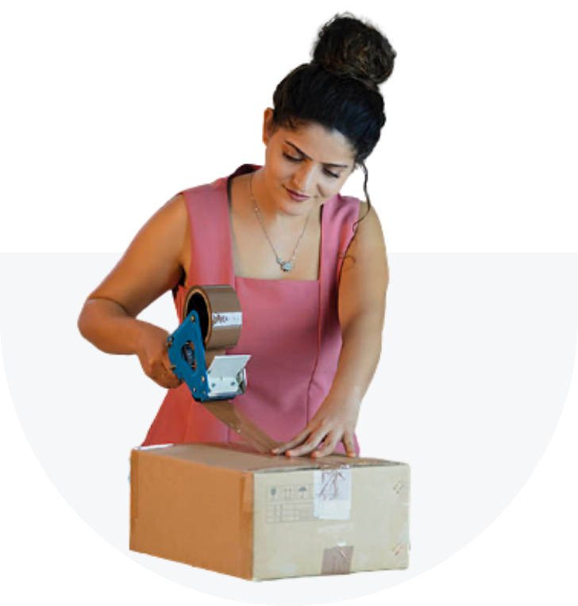

Meesho Return Policy
- The Meesho Supplier Panel will provide visibility for returns on your inventory. This means you can make adjustments in real-time and deliver a great customer experience and minimize your returns. Use the Panel to manage your returns and reduce your processing costs.
Cancellation
- Meesho charges 0 penalties for supplier cancellations and auto cancellations. For situations when a supplier is not able to fulfil an order due to lack of inventory or any other unforeseen situation, suppliers can conduct their business tension-free on Meesho without worrying about the fear of paying penalties.

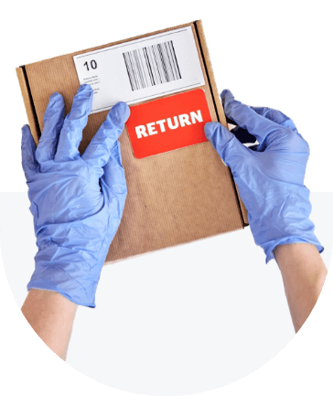
Return to Origin
- The shipping partner will try three times to reach the customer. If the customer does not accept the product, it will be returned to you. Meesho will not charge a return shipping fee for any RTOs.

